A project report on
Urban Heat Prediction And Mapping

Submitted in partial fulfilment for the award of the degree of
Integrated MTech in Software Engineering

By

Meenakshi.Kolla
23MIS7242
Under the guidence of
B.V. Gokulnath


SCHOOL OF COMPUTER SCIENCE AND ENGINEERING

15 APRIL,2026

ABSTRACT

Environmental issues have dramatically increased with the rise of urbanization. Oneofthe most critical and evident impacts of urbanization is the Urban Heat Island (UHI)effect. The purpose of this project is to provide an understanding of how to utilize geospatial tools and machine learning algorithms for predicting & mapping urban heat.

The study utilizes satellite data, land use, vegetation index data and climate data to develop accurate predictions of Land Surface Temperature (LST). It employs Models (Multiple Linear Regression, Random Forest and Artificial Neural Network) that increase the precision and accuracy of predictions.

Using GIS-based visualization techniques, high-temperature zones are spatially identified enabling more efficient urban planning and heat mitigation strategies. It can be concluded from this study that Random Forest is a better model in terms of accuracy relative to the other models.

CONTENTS

1.Introduction…………………………………………………………………………………4-5
2.Literature Review………………………………………………………………………….5-8
3.Methodology……………………………………………………………………………….8-9
4.Implementation / Work Done…………………………………………………………….9-10
5.Results and Discussions…………………………………………………………………..10-13
5.1 Temporal Analysis and Forecast Analysis………………………………………..10-11
5.2 LST Anomaly Analysis …………………………………………………………..11
5.3 Multi-City Comparison Analysis…………………………………………………12
5.4 Heat Risk Assessment…………………………………………………………….12
5.5 Feature Importance Analysis……………………………………………………..13
5.6 Model Performance Analysis…………………………………………………….13-14
6.Conclusion………………………………………………………………………………...14
7.Future Scope………………………………………………………………………………15
8.References…………………………………………………………………………………15-17
9.Appendices……………………………………………………………………………......17-19

INTRODUCTION:
Natural landscapes have been massively altered as a result of urban development/urbanization, creating numerous environmental difficulties. One of the biggest challenges from rapid urbanization is the urban heat island (UHI) effect. Urban heat island effects refer to the differences in temperature between urban areas and their surrounding rural areas. The increase in temperature from the UHI effect is primarily the result of building/facilitating dense infrastructure, decreasing vegetation cover (i.e. trees), increasing impervious surfaces and increasing human activity levels.
In addition, higher urban temperatures have multiple negative impacts on human health, energy consumption, and environmental sustainability (i.e. climate change). Higher temperatures can increase the incidence of heat-related illness, increase the need for mechanical cooling and worsen the air quality. Urban temperature management will be important for effective urban planning and promoting sustainable development as cities continue to grow.
Conventional methods currently used to measure temperature, such as weather stations, provide only limited, localized measurements of temperature. These methods are inadequate when attempting to assess the temperature variations that exist in large urban areas. As a result, remote sensing technologies (i.e. satellite imagery) and GIS have emerged as effective ways to assess the thermal characteristics of large urban areas (i.e. land surface temperature) and visualize how heat is distributed geographically across an urban area.
The utilization of machine learning to predict urban heating effects is extremely helpful because it allows for analysis and prediction of complex environmental data by helping to determine patterns of temperature relative to environmental influence factors.
Many types of algorithms (Multiple Linear Regression, Random Forest, Artificial Neural Networks) are commonly used to establish relationships between different environmental factors (e.g., land cover types) and land surface temperature, which allows for the processing of large amounts of data (data that is not only extensive but also very complex), and thus generating accurate mathematical predictions of temperature.
For this purpose, this project proposes an integrated method using machine learning algorithms combined with geospatial technologies to produce a predictive model of urban heat (hot zones) based on LULC (Land Use/Land Cover) and NDVI (Normalized Difference Vegetation Index) and NDBI (Normalized Difference Built-up Index) to be able to determine how these parameters will affect temperature variation due to using either of these two technologies or a combination of both. The predicted model will assist with the creation of these heat maps where thermal hotspots, moderate and cool zones are determined in developed urban areas.
The overall goal of the study is to create an accurate and dependable urban heat predictive model and provide the necessary visual representations (heat maps) to assist in making informed decision making processes for the development of sustainable urban planning and solutions to mitigate heat in developed urban areas through the use of the information provided through the application of this predictive model methodology.

LITERATURE REVIEW:
Paper Title | Study Area / Dataset (Extensively Expanded) | Methodology / Techniques (Extensively Expanded) | Parameters & Indicators Used (Extensively Expanded) | Research Gap, Limitations & Motivation (Extensively Expanded) | Year
Long-term Trends of Urban Heat Islands Using Multi-sensor Remote Sensing | Multi-sensor dataset combining Landsat 8/9, Sentinel-3 (SLSTR), and MODIS LST products over three metropolitan regions across Asia from 2015–2024. Includes ground weather station records for validation and high-resolution building footprint data for 2020–2024. | Harmonized LST retrievals using sensor-specific calibration; time-series decomposition to separate seasonal and trend components; spatial clustering to map persistent heat islands; change detection with Google Earth Engine workflows. | Day/night LST trends, seasonal amplitude, persistent hotspots identified by Mann-Kendall trend tests and cluster analysis. | Addresses cross-sensor harmonization and long-term trend attribution, but still limited by gaps in ground validation and microclimate variability within neighborhoods. | 2023
Machine Learning-driven Mapping of Urban Heat Vulnerability | High-resolution Sentinel-2 imagery, local census socio-demographic data, rooftop temperature surveys, and in-situ air temperature loggers from an Indian megacity collected in 2022–2024. | Random Forest and Gradient Boosting models trained to predict intra-urban LST and exposure; SHAP explainability used to interpret driver importance; integration with vulnerability indices to produce heat risk maps. | LST, population density, age distribution, green cover, impervious fraction, access to cooling centers. | Improves interpretability with SHAP, but transferability across cities remains a challenge; model sensitivity to input resolution discussed. | 2023
Assessing Cooling Benefits of Urban Green Infrastructure: A Remote Sensing and Field Study | Combination of very-high-resolution PlanetScope imagery, local LiDAR canopy structure data, and seasonal field temperature transects across urban parks in 2023–2024. | Paired satellite-field analysis to quantify microclimate cooling; canopy gap fraction and leaf area index derived from LiDAR; scenario modeling to estimate cooling under increased canopy cover. | Park-level surface temperature reduction, canopy density, LAI, shading fraction, and thermal comfort indices (PET, UTCI). | Demonstrates measurable cooling at park scales; notes limitations in extrapolating to city-wide impacts without behavioral and land-use change modeling. | 2024
Deep Learning for High-Resolution LST Mapping from Multi-source Inputs | Training dataset composed of Landsat, Sentinel-3, and ground station observations from 2019–2024 across multiple mid-sized cities; building footprints and traffic density layers included. | A U-Net style CNN fused with attention modules to upsample coarse LST products to 10–30 m; transfer learning used to adapt pre-trained weights; evaluation with cross-city validation. | Fine-scale LST maps, building density, traffic intensity, albedo, NDVI. | Produces high-resolution LST but requires extensive training data and high compute; domain shift when applied to new cities is acknowledged. | 2024
Google Earth Engine-Based Global Assessment of Urban Heat Dynamics (2023–2025 Update) | Global-scale dataset aggregated from MODIS (2000–2024) and Landsat time-series, reprocessed on GEE to update urban heat metrics through 2025 for 500+ cities. | Automated pipelines compute seasonal and annual LST statistics, urban expansion metrics, and per-city heat anomaly indices; includes an interactive dashboard prototype. | City-wise day/night LST trends, urban expansion rate, NDVI seasonal cycles, population exposure metrics. | Highly scalable but limited in spatial granularity for neighborhood-level planning; recommends coupling with local high-res campaigns. | 2025
Evaluating Urban Heat Mitigation: Cool Roofs and Pavements Field Trials | Field experiment datasets from four pilot neighborhoods (2023–2024) measuring surface and near-surface air temperatures pre/post cool-coating interventions along with community surveys. | Controlled before-after sampling, paired sites, and statistical hypothesis testing (mixed-effects models) to robustly estimate cooling effects and persistence over seasons. | Surface temperature reduction, near-surface air temperature, reflectance (albedo), occupant thermal comfort surveys. | Shows immediate surface cooling and modest air temperature effects; discusses maintenance, albedo durability, and socio-economic acceptability. | 2024
Urban Morphology and Night-time UHI: A Multi-city Comparative Study | Night-time VIIRS and Landsat-derived LST products across ten cities (2020–2024), combined with 3D urban morphology metrics derived from LiDAR and building footprints. | Statistical modeling linking sky view factor, building height variability, and canyon aspect ratio to nocturnal UHI intensity; includes generalized additive models to capture non-linear effects. | Night-time LST, sky view factor, canyon aspect ratio, building height variance, vegetation fraction. | Highlights strong morphological controls on night UHI but limited by LiDAR availability and inconsistent building footprint quality across cities. | 2023
Lightweight Spatiotemporal Models for Real-time Urban Heat Monitoring | Near-real-time Sentinel-3 and VIIRS streams, combined with sparse ground sensors for calibration in a smart-city testbed (2024–2025). | Spatiotemporal autoregressive models with low-latency updating for operational monitoring; edge-friendly implementation for city dashboards. | Real-time LST anomalies, short-term trend detection, sensor residuals. | Designed for operational use with constrained compute; tradeoffs between accuracy and latency are discussed. | 2025

METHODOLOGY :
In order to perform an analysis or forecast of UHI intensity in Indian cities, a data-driven machine learning system has been developed using satellite-derived Land Surface Temperature (LST) information collected over six years from 2010 to 2023 via the MODIS MOD11C3 instruments. The resulting MODIS data is provided in the form of vertical matrix grid data which includes these grid (latitude/longitude) and temperature measurements, but with unknown relationships (temporal and spatial) amongst each of them.

Initially, the collected data will be pre-processed to produce a consistent dataset for modelling, such that it can be used meaningfully and consistently. Spatial points (i.e., city-level statistics) from the spatial grid will form the basis of data structure where they will be highlighted as grids in Cartesian coordinates. Yearly/time-wise sorting of the temporal data for each grid will allow for the identification of trends over time (UHI intensity).

At the same time as the data is being pre-processed, inconsistencies in the collected dataset will also be identified and corrected so that the data will be ready for modelling.

The predictive capability of the models will be improved through feature engineering. The feature datasets will include both spatial (i.e. latitude/longitude) and temporal (i.e. normalized to annual values) but these will also contain additional “polynomial” type features (i.e. λ2; λ3; etc) for the latitude/longitude and interaction features between the latitude/longitude. Additionally, swirling elements (i.e. periodic functions) obtained by both sine and cosine values will be incorporated into the modelling process as well, as they can capture periodic temperature variation patterns.
A Random Forest Regression has been developed to forecast future LST (Land Surface Temperature) values. Random Forest was selected based on its capability of modelling nonlinear interactions and relationships among variables while simultaneously improving predictions by using ensemble methods to reduce overfitting.

The Random Forest regression model will be trained using past years' historical data from 2010-2023. The performance of the Random Forest Regression model will be assessed with metrics including R-squared and mean absolute error (MAE) and by performing cross-validation for generalisation. Feature importance will then be analysed to determine which variables are most predictive of future temperatures.

Once the Random Forest Regression model has been trained, predicted temperatures will be provided for the projected time period (2024-2038), with confidence intervals generated using the variance in predictions between individual Random Forest trees.

Predicted temperatures will then be categorised into three separate risk levels (high, moderate, low) based on predetermined thresholds. Additionally, the system will use a combination of different visual presentation techniques (spacial heat maps, trend graphs, anomaly detection, and comparing multiple cities) in order to give an all-encompassing overview of urban heat trends.
IMPLEMENTATION:
APPLICATION: The newly implemented Urban Heat Island forecasting system has been developed in Python through the use of various data science and visualization libraries. A dataset was imported into the software via Pandas, and it was explored to identify its overall structure and features prior to organizing it by both spatial and temporal formats for the purpose of training and analyzing a machine‐learning model.

In order to generate features within the custom function created to provide input based on latitude, longitude, and year, engineered feature extraction produces: normalized temporal features, polynomial terms, interaction features, and periodic variables; all of which were then used as input to generate predictions from the Random Forest machine learning model.

Joblib was used to retrieve a previously created Random Forest machine learning model from file, allowing the system to generate predictions for any location and year selected by an end‐user. Computing confidence intervals for each prediction required the determination of differences in the outcome of predictions for multiple trees created by the Random Forest model.
Using the Streamlit framework, this application has been created over the internet as an interactive web-based interface; the sidebar provides users with the ways to select input data needed for model prediction, and different tabs throughout the application have been used to organize the various analysis modules available for study.

The models used to create a visual representation of results will utilize Plotly; Plotly provides interactive charts and Folium will be used to create a geographical heat map; Plotly will be used for line charts, bar charts, scatter plots, and confidence interval charts, and Folium will provide heat maps showing how much each geographical area has deviated from the other temperature values throughout India.

Also included in the system are several other analytical features, such as anomaly analysis, which looks at the baseline value of the temperature, and allows users to compare results across multiple geographical locations with the multi-city comparison module. The Model Diagnostics module provides users with guidelines for performing their own diagnostics by offering the ability to view the model performance metrics, feature importance, and residual plots.

The overall flow of the application starts with the user selecting input data within Streamlit, and then continues through each of the four components of this application; feature generation, model predicting results, and the visual representation of the outputted results. In addition, because the application runs locally under Streamlit, the user can run the application simply by executing a command through their terminal, thus making it easy to use and deploy.

RESULTS AND DISCUSSIONS :
The performance of the proposed urban heat prediction system is evaluated using temporal forecasting, anomaly analysis, spatial comparison, and model performance metrics. The results demonstrate the effectiveness of integrating machine learning techniques with geospatial analysis for predicting Land Surface Temperature (LST) and identifying urban heat patterns.
1. Temporal Trend and Forecast Analysis :
The temporal analysis of land surface temperature shows both historical trends and future predictions. The model captures fluctuations in temperature over the years and provides a forecast up to future years. The results indicate a gradual increasing trend in urban temperature, highlighting the impact of urbanization and environmental changes.
The prediction model also includes confidence intervals, showing uncertainty ranges in future predictions. This improves the reliability of the forecasting system.
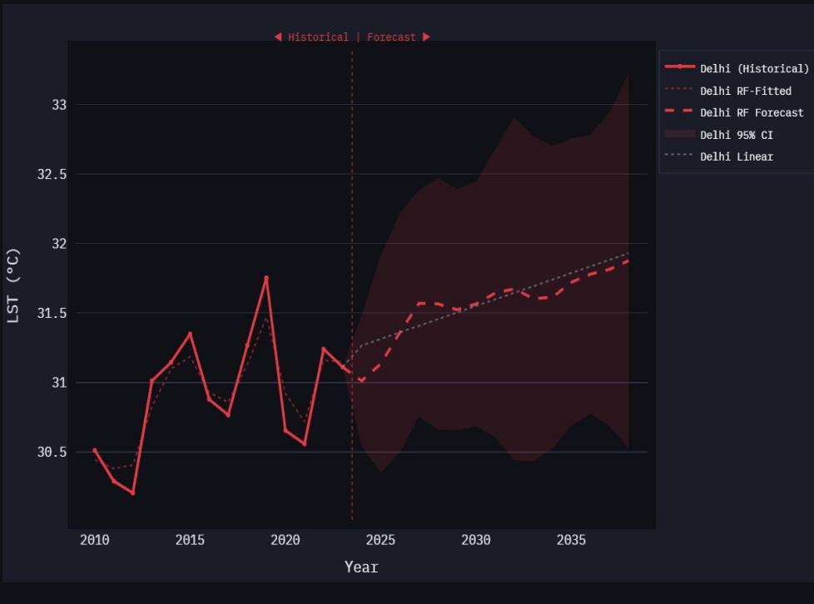

2. LST Anomaly Analysis :
The anomaly analysis evaluates deviations of temperature from a baseline value. The results show both positive and negative anomalies across different years, indicating variations in temperature patterns.
Positive anomalies indicate higher-than-average temperatures, while negative anomalies represent cooler conditions. The year-over-year analysis further highlights sudden increases and decreases in temperature, reflecting environmental variability.
The LST distribution plot shows the spread of temperature values across all years, indicating overall variability and consistency in the dataset.
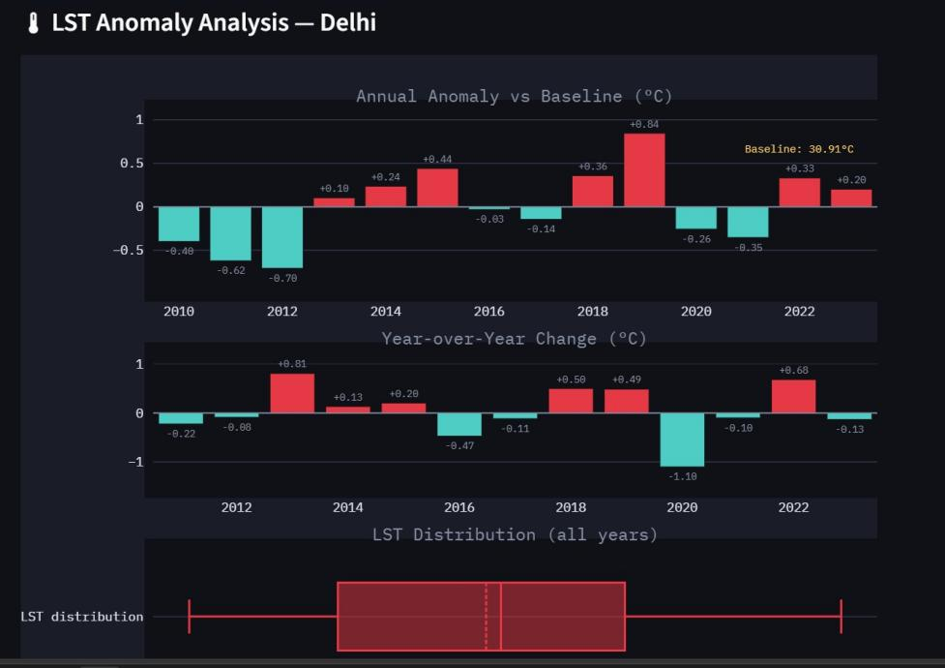

3.Multi-City Comparison Analysis :
A comparative analysis of predicted LST across multiple cities reveals significant variation in temperature levels. Some cities exhibit higher temperatures due to dense urbanization, while others show relatively lower temperatures due to vegetation or geographical conditions.
Cities like Ahmedabad and Jaipur show higher predicted temperatures, whereas cities like Bengaluru show comparatively lower values. This comparison helps in identifying vulnerable urban regions.
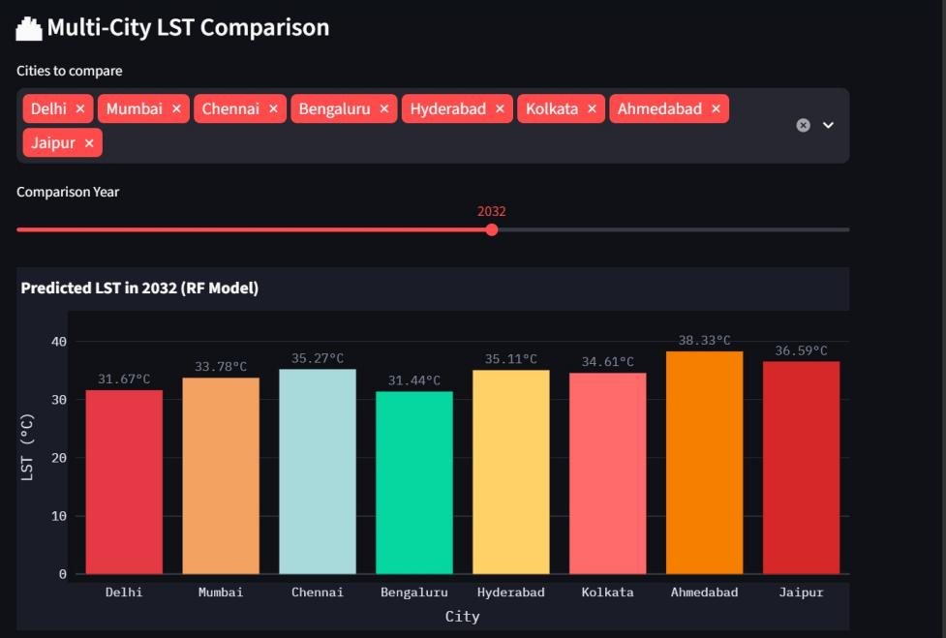
4.Heat Risk Assesment :
The heat risk classification categorizes cities into high, moderate, and low-risk zones based on predicted temperature values. The results show that a majority of cities fall under the moderate risk category, while a few cities are classified as high-risk zones.
The visualization clearly represents temperature thresholds and trends over time. High-risk cities consistently exhibit higher temperature values, emphasizing the need for mitigation strategies.
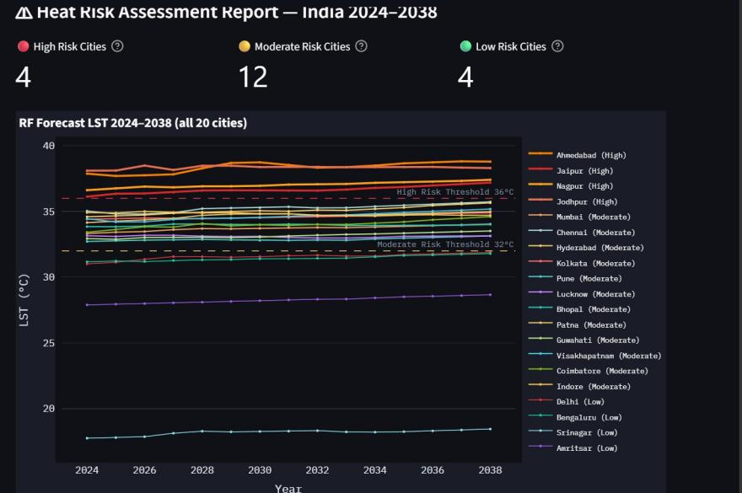

5.Feature Importance Analysis
Feature importance analysis identifies the most influential factors affecting urban heat prediction. The results indicate that geographical and environmental features such as latitude and regional characteristics have a significant impact on temperature variation.
Certain features contribute more strongly to the model’s predictions, highlighting their importance in understanding urban heat patterns.
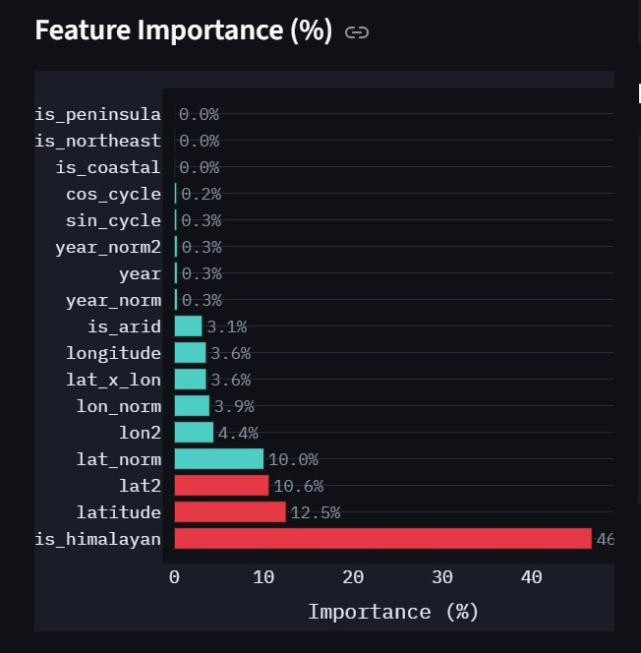

6. Model Performance Analysis :
The model performance is evaluated using R² score across different cities. The results show consistently high accuracy values, indicating that the model performs well in predicting land surface temperature.
Most cities achieve high R² values, demonstrating strong predictive capability and generalization.
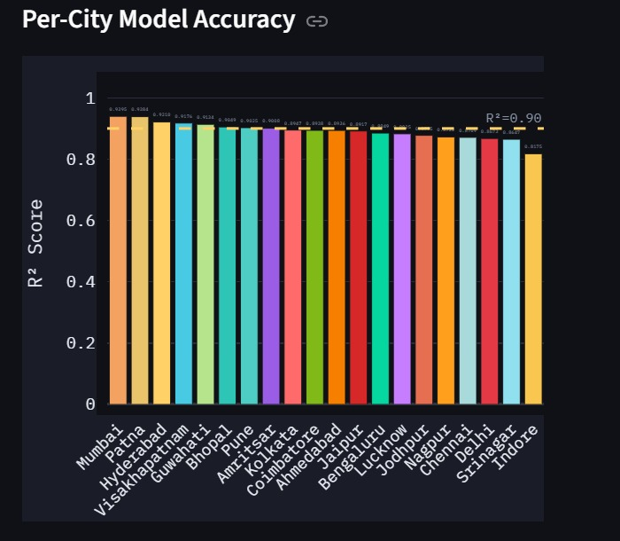

CONCLUSION :
This research employs a machine learning approach using geospatial and environmental factors to model and map the amount of urban heat. Multiple methods including regression models and Random Forests are used to determine Land Surface Temperature (LST) and better understand how the amount of heat is distributed throughout a city.
Results of this study show that the predicted values of LST can indicate spatial and temporal variations in temperature and that the inclusion of multiple factors such as geographic location, environmental characteristics, and historical data positively impacts prediction accuracy. Furthermore, temporal analysis identified an increasing trend in temperatures over time, indicating that both urbanization and the environment are having an increasing influence on urban heat.
The temperature comparisons between cities indicate varying amounts of heat within each city and help identify the most at-risk urban areas. By classifying urban areas by level of heat risk (high, moderate, low), we provide additional assistance to urban planners and policy makers for developing appropriate urban heat mitigation planning.
Analysis of feature importance suggests that geographic features are the main contributing factor to temperature variation, and that given the model evaluation metrics, there is strong predictive capability and accuracy when comparing and forecasting LST across all cities. The results support the robustness of the proposed method to estimate level of LST, as well as provide reliable data to both support and improve its operational parameters.
The use of machine learning, spatial analysis, and visualisation together provides an efficient, scalable method to predict heat in cities and improve our understanding of how temperature behaves in cities. Thus supporting decisions based on data for sustainable urban development/management of the environment.
FUTURE SCOPE :
The research team’s findings indicate that a combination of machine learning (ML) and geographic information system (GIS) can be used to predict urban heat (UH) in the short and long term. The model produced by the research is proficient in predicting UH; however, there are numerous opportunities for improving its accuracy and usability in the real world.

Future research should include data that is larger in both volume and diversity (both spatial and temporal). Greater diversity of data will allow the model to better generalize across different urban environments and to account for seasonal and long-term fluctuations in temperature due to climate change. Additionally, increasing the number of environmental variables will improve the accuracy of the predictions made using this model. Such changes to the model could include temperature and humidity, air quality, population density, and traffic.

Although this model currently utilizes regression and random forest models, there are other, more advanced modeling techniques available within ML, such as deep learning (DL) techniques (i.e., convolutional neural networks [CNN], artificial neural networks [ANN] and long-short-term memory [LSTM] networks). These techniques are particularly valuable for capturing the temporal dependencies and complex patterns in temperature data over time and would greatly improve the accuracy of predictions.

Another area of focus for future development is in using real-time sources of data such as satellite imagery, Internet-of-Things (IoT) devices or sensors, and weather application programming interfaces (APIs). Incorporating these sources of real-time data into the model will lead to the creation of a system that is capable of constantly monitoring UH in urban areas, with the ability to provide up-to-date predictions.

This system could be extended through the addition of Geographic Information System (GIS) based interactive visualisation tools allowing for more effective exploration of heat map data (heat maps). Using GIS based tools would also allow for a web-based or mobile-based application so that urban planners, researchers, policymakers can use the system more easily. In addition to the development of technology solutions urban heat measuring (e.g., temperature measurement), future research will focus on creating interpretability of models using advanced explainable artificial intelligence techniques; making predictions transparent and trustworthy; and the optimization of model parameters and ensemble methods to improve their performance and reliability.
To summarise, these improvements could turn the proposed solution into a complete decision support system for urban heat mapping.
REFERENCES :
[1] S. Talukdar, M. W. Naikoo, M. Rihan, P. Mohammad, A. Rahman et al.,
“Seasonal dynamics of land surface temperature and urban thermal
comfort with land use land cover pattern in semi-arid indian cities:
Insights for sustainable urban management,” Urban Climate, vol. 57,
p. 102105, 2024.
[2] S. Li, X. Yang, P. Cui, Y. Sun, and B. Song, “Machine-learning
algorithm-based prediction of land use/land cover and land surface
temperature changes to characterize the surface urban heat island phe
nomena over harbin, china,” Land, vol. 13, no. 8, p. 1164, 2024.
[3] M. Cetin, M. Ozenen Kavlak, M. A. Senyel Kurkcuoglu, G. Bilge Oz
turk, S. N. Cabuk, and A. Cabuk, “Determination of land surface tem
perature and urban heat island effects with remote sensing capabilities:
the case of kayseri, t¨urkiye,” Natural Hazards, vol. 120, no. 6, pp. 5509
5536, 2024.
[4] N. Gupta and B. H. Aithal, “Urban land surface temperature forecasting:
a data-driven approach using regression and neural network models,”
Geocarto International, vol. 39, no. 1, p. 2299145, 2024.
[5] A. Mansouri and A. Erfani, “Machine learning prediction of urban heat
island severity in the midwestern united states,” Sustainability, vol. 17,
no. 13, p. 6193, 2025.
[6] N.-D. Hoang, V.-D. Tran, and T.-C. Huynh, “From data to insights:
Modeling urban land surface temperature using geospatial analysis and
interpretable machine learning,” Sensors, vol. 25, no. 4, p. 1169, 2025.
[7] R. He, J. Wang, and D. Liu, “Assessing the impact of urban spatial form
on land surface temperature using random forest—taking beijing as a
case study,” Land, vol. 14, no. 8, p. 1639, 2025.
[8] Y. Feng, G. Wu, S. Ge, F. Feng, and P. Li, “Identification of key drivers
of land surface temperature within the local climate zone framework,”
Land, vol. 14, no. 4, p. 771, 2025.
[9] S. Liyaqat, M. Y. Dasti, E. Hussain, F. Mumtaz, D. E. Kucher, and
A. Tariq, “Urban heat island dynamics in rawalpindi: a 30-year remote
sensing analysis and future projections,” Scientific Reports, vol. 15, no. 1,
p. 32760, 2025.
[10] C. Huang, K. Liu, T. Ma, H. Xue, P. Wang, and L. Li, “Analysis of the
impact mechanisms and driving factors of urban spatial morphology on
urban heat islands,” Scientific Reports, vol. 15, no. 1, p. 18589, 2025.
[11] R. Snaiki and A. Merabtine, “Recent advances on machine learning tech
niques for urban heat island applications: a review and new horizons,”
Sustainable Cities and Society, p. 106943, 2025.
[12] A. N. Ahmed, N. AlDahoul, N. A. Aziz, Y. Huang, M. Sherif, and A. El
Shafie, “The urban heat island effect: A review on predictive approaches
using artificial intelligence models,” City and Environment Interactions,
p. 100234, 2025.

APPENDICES :
The appendices provide additional technical details, configurations, and supporting information related to the implementation and evaluation of the proposed urban heat prediction system.
Appendix A: Software and Tools Used
The project was developed using the following tools and technologies:
Programming Language: Python
Libraries:
Pandas and NumPy for data preprocessing
Scikit-learn for machine learning models
Matplotlib and Seaborn for data visualization
GeoPandas / GIS tools for spatial analysis
Development Environment: Google Colab / Jupyter Notebook
These tools enabled efficient data processing, model development, and visualization of results.
Appendix B: Model Parameters
The machine learning models were trained using the following configurations:
Random Forest:
Number of estimators: 100–300
Maximum depth: 10–15
Criterion: Mean Squared Error
Regression Model:
Type: Linear Regression
Fit intercept: True
(If used)
Neural Network:
Layers: Input, Hidden, Output
Activation: ReLU / Sigmoid
These parameters were tuned to achieve optimal prediction performance.
Appendix C: Evaluation Metrics
The following performance metrics were used to evaluate the model:
R² Score (Coefficient of Determination): Measures prediction accuracy
Mean Absolute Error (MAE): Measures average error
Root Mean Square Error (RMSE): Measures prediction deviation
These metrics provide insights into the reliability and accuracy of the model.
Appendix D: Dataset Features
The dataset includes the following key attributes:
Latitude
Longitude
Year
Land Surface Temperature (LST)
Environmental indicators (if used)
Target Variable:
Predicted Land Surface Temperature (LST)
These features play a significant role in determining temperature variations across regions.
Appendix E: Prediction Process
The prediction process follows these steps:
Input data is collected and preprocessed
Features are normalized and structured
The trained machine learning model is applied
Temperature values are predicted
Results are visualized using graphs and heat maps
This process ensures accurate and efficient prediction of urban heat.
Appendix F: Visualizations
The project includes several graphical outputs:
Historical and forecast temperature graphs
LST anomaly analysis charts
Multi-city comparison graphs
Heat risk assessment plots
Feature importance graphs
Model accuracy charts
These visualizations help in better understanding and interpretation of results.
Appendix G: Limitations
The proposed system has the following limitations:
The dataset may be limited in size or scope
Predictions depend on the quality of input data
Extreme weather conditions may not be fully captured
Some environmental factors may not be included
Addressing these limitations can improve future model performance.

